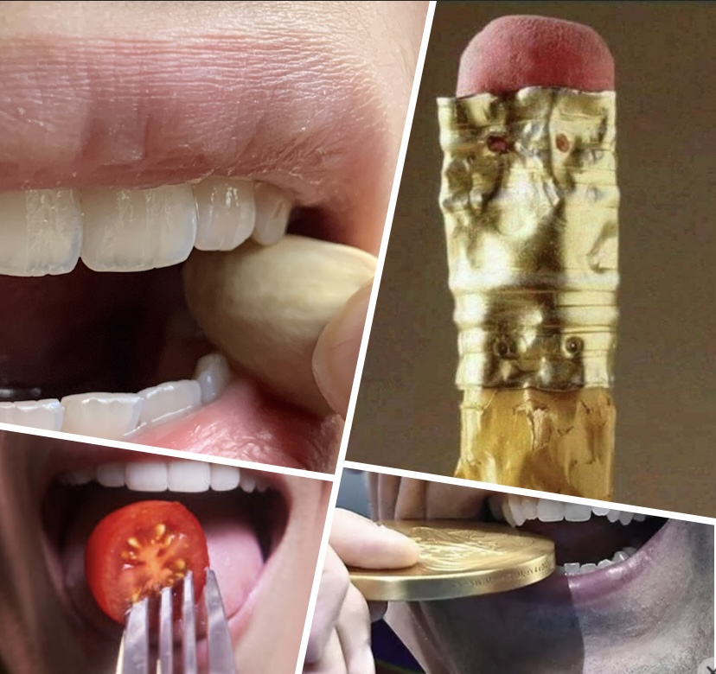

Maintenance of your new restoration
1-Prevent fracture
Your restoration is made of high standard Ceramic material which suits for your case.
This doesn't mean that they are unbreakable, same as any other material which brakes under excessive force and pressure.
A-Stress can trigger jaw clenching or teeth grinding. This places a severe amount of pressure on your teeth which can fracture your dental work. If you tend to grind at night, ask your dentist for a night guard. If you engage in contact sports, wear an appropriate sport guard.

B-Many people use their teeth to break off a tag on clothing, Open pistachio , rip open packages or staples, bite fingernails, or crack seeds and nuts. Teeth are not pliers or hooks.
Using your teeth as a tool is a threat to your dental work just as it is to your natural teeth. Also beware of sharp impacts and hard objects such as a drinking glass, a spoon, and chewing ice or hard candy.

2- Hygiene
A-You can still develop tooth decay even when you have veneers or crowns. The margin where the restoration meets your natural teeth is a particularly susceptible area. Protect your investment by flossing every day, cleaning under your bridge, and having regular cleanings and checkups. A beautiful smile is highly influenced by a healthy and pinky gum .Ask your dentist how to take care of your gum.
B-Always tell your dentist or dental hygienist that you have veneers, crowns, or bridges. Most of the times, our restorations matches existing teeth so perfectly, it takes a second closer look to find which one is fake! So please speak up before your Hygienist starts scraping with an Ultrasonic pen. We would advise against the use of a cavitron. It can scratch and debond your restoration. Cleaning the margins of a porcelain restoration requires a gentle manual scraper.

